How to setup Motion detection alarm and send photo to email
1th,pls connect your ip camera to your router,and Make sure the camera and your PC with same LAN(same gateway )
2th,pls login your ip camera in IE,go settings,click Motion detecting:
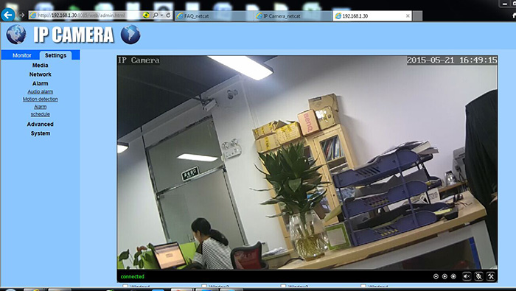
3Th,choose motion detecting window,MAX choose 4 windows
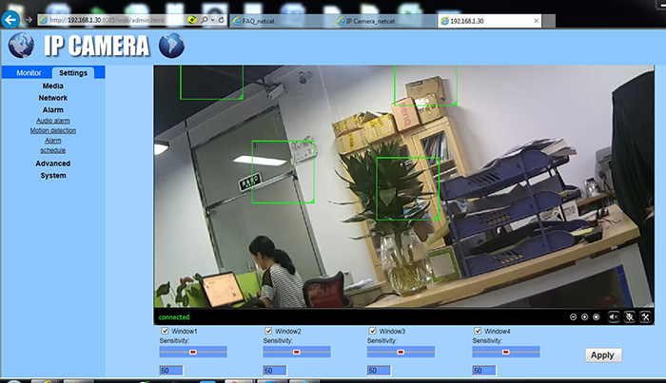
4Th,Click Apply,and find alarm,and click alarm,choose E-mail alarm and send with picture,and choose image capture,number max support 3 images
Then pls click Email setting for setting Email smtp service.
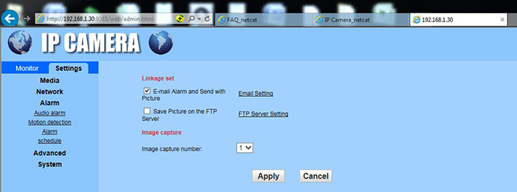
5Th,there is setup Email mail service,pls look this pic
outlook email for example:
SMTP server name:smtp.live.com server port:587
safe link:STARTTLS Authentcation:on username:abrsell@outlook.com pwd:xxxxxxx
send to :netcatcctv@outlook.com,sender:abrsell@outlook.com, subject:alarm ,Message:alarm
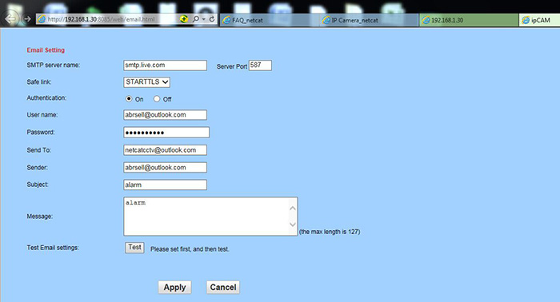
6Th,Click Test,test your setup
Oh,great,tet success!,pls click Apply
7Th,OK,let me go my netcatcctv@outlook.com email box,check alarm email,
pls see,i got 2 email for alarm,let me open it
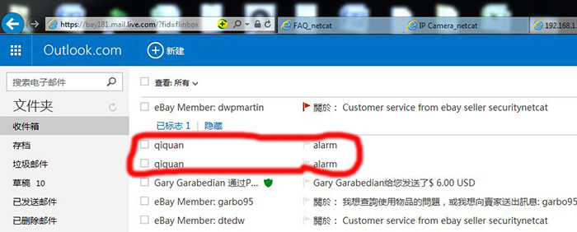
wowo,great,i got alarm message and alarm Picture,very good

